create table Registration

(

Name varchar2(40),

Email varchar2(40),

Password varchar2(40)

);

insert into Registration(Name,Email,Password) values('Jinappa','jinappa90@gmail.com','jinu123');

insert into Registration(Name,Email,Password) values('Robert','Robert670@gmail.com','Rob1@8987');

insert into Registration(Name,Email,Password) values('Fatima','fatimaA85@gmail.com','Rfat@6785');

**select * from Registration**

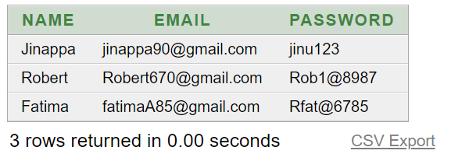

**Desc Registration**

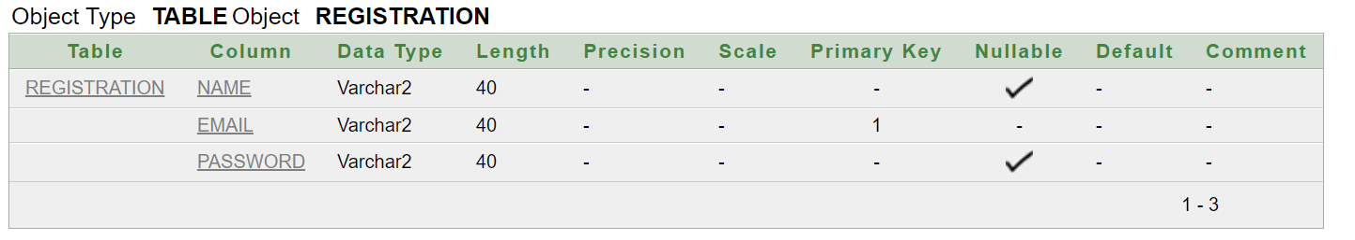

create table Volunteer

(

Name varchar2(40),

Email varchar2(40),

Address varchar(500)

);

insert into Volunteer(Name,Email,Address)values('Malini','mali@gmail.com','2nd block Btm banglore');

insert into Volunteer(Name,Email,Address)values('Remo','remoserro@gmail.com','#21street uttarahalli');

insert into Volunteer(Name,Email,Address)values('Fatima','mali@gmail.com','#21 sampige Banglore');

**select * from volunteer**

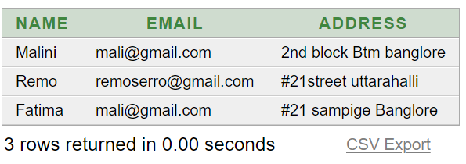

**Desc Volunteer**

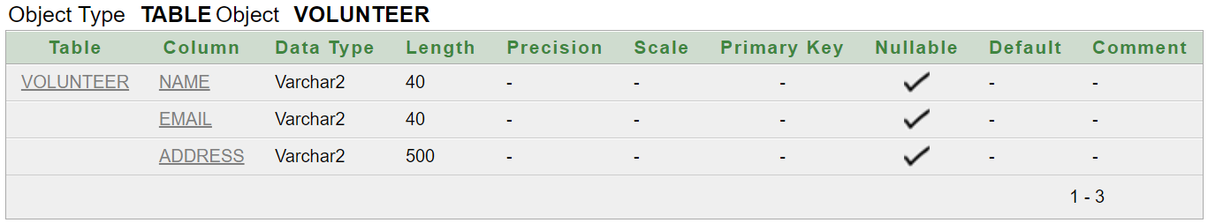

**Registration Form**

|  |  |
| --- | --- |
| **Name** |  |
| **Email** |  |
| **Password** |  |

**Submit**

**Volunteer Form**

|  |  |
| --- | --- |
| **Name** |  |
| **Email** |  |
| **Address** |  |

**Submit**